**Business Plan**

**G-Sustainabl**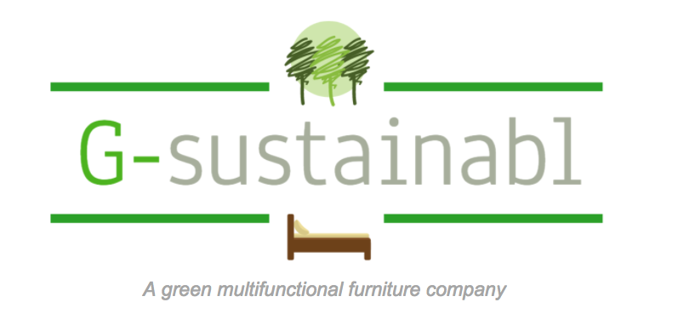

**Presented to Prof. Alexander Kalil**

**BUSA 665-002 Managing the Small Enterprise**

|  |  |
| --- | --- |
| Andy Zhang | 260752195 |
| Zahra Holder | 260739311 |
| Yaqiong Deng | 260723306 |
| Wei Yang | 260726651 |
| Jia Pu | 260718994 |
| Philipp Fischer | 260455953 |
| Alissina Shahabi | 260533523 |

**Executive Summary**

G-Sustainabl is a green multifunctional furniture start-up located in Montreal, Quebec. We design, manufacture, and retail wall-beds, table-beds, and smart shelves targeted at student apartments, millennials, and small families in Montreal. Our goal is to maximize living space while placing great value in comfort and environmental sustainability. Thus, our furniture incorporates the use of sustainable raw materials, unique Mortise-Tenon joint design, and multifunctional structure.

We plan to capitalize on new trends within the furniture industry, wherein multifunctional and versatile furniture has risen in popularity amongst the student and millennial population groups. In addition, growing environmental consciousness and concern has led to the increased demand for ecologically friendly furniture. Our competitive advantage lies within our ability to seamlessly integrate these factors without sacrificing quality. We implement a strategic omni-channel sales approach and employ a dedicated service team that is customer-centric. On our operations side, we have adopted an integrated sales and production management system, and our facilities are equipped with the latest technologies to allow for automation and to maintain quality control.

We intend to finance the start of our business with a bank loan of $200,000 and $50,000 from friends and family. Our financial projections forecast a revenue growth to $921,280 by the fourth year of operations, with a gross margin of 54%. This will provide us with a positive cash flow over our first four years of business. Net income is projected to reach $103,036 in year four as sales increase and we optimize our operations.

**Table of Contents**

1. Company…..................................................................................................................................4

1.1 History………………………………………………………………………………………..4

1.2 Legal and Corporate Structure.................................................................................................4

1.3 Vision and Mission..................................................................................................................5

1.4 Existing Customers and Partners.......................................................................................... ..6

2. Market Analysis...........................................................................................................................7

2.1 Market opportunity and sizes...................................................................................................7

2.1.1 US market overview...........................................................................................................8

2.2 Short- and long-term segments..............................................................................................10

2.3 Market Trends and Drivers....................................................................................................10

2.4 Market Environment..............................................................................................................11

2.4.1 E-commerce......................................................................................................................12

2.5 Challenges..............................................................................................................................13

2.6 Target Customers and Regions..............................................................................................13

2.6.1 University students (Montreal).........................................................................................13

2.6.2 Millennials (Montreal)......................................................................................................15

2.6.3 Small Families (Montreal)................................................................................................17

2.6.4 Short-term rentals (Montreal)...........................................................................................17

2.6.5 Mini hotels (Japan and Hong Kong).................................................................................18

2.7 Phase of Market Development...............................................................................................18

2.8 Value chain............................................................................................................................19

3. Competition................................................................................................................................19

3.1 Direct Competitors.................................................................................................................20

3.2 Indirect Competitors..............................................................................................................20

3.3 Competitive Advantage.........................................................................................................21

3.4 Advantage of Subcontracting.................................................................................................22

4. Products......................................................................................................................................23

4.1 Description.............................................................................................................................23

4.2 Product Features.....................................................................................................................24

4.2.1 Mortise-Tenon Joint..........................................................................................................24

4.2.2 Environmental Footprint..................................................................................................25

4.2.2.1 Materials......................................................................................................................25

4.2.2.2 Packaging.....................................................................................................................26

5. Services......................................................................................................................................26

5.1 Purchasing Support................................................................................................................26

5.2 Delivery..................................................................................................................................27

5.3 Product Support.....................................................................................................................27

5.4 Return and Exchange Policy..................................................................................................28

5.5 Quality Assurance..................................................................................................................28

6. Sales and Marketing...................................................................................................................28

6.1 Marketing Strategy.................................................................................................................28

6.2 Sales Strategies......................................................................................................................29

6.3 Channel Sales and Direct Sales..............................................................................................30

6.4 Revenue model.......................................................................................................................31

6.5 Sales Funnel...........................................................................................................................31

7. Operations..................................................................................................................................33

7.1 Information technologies – integrated sales & production management...............................33

7.2 Quality....................................................................................................................................34

7.3 High-Tech Equipment............................................................................................................34

7.4 Facilities.................................................................................................................................34

7.5 Personnel................................................................................................................................35

8. Financial Plan.............................................................................................................................35

8.1 Income Statement Assumptions – Revenues.........................................................................35

8.2 Income Statement Assumptions - Cost of Sales....................................................................37

8.3 Income Statement Assumptions - Expenses..........................................................................37

8.4 Balance Sheet Assumptions...................................................................................................38

8.5 Cash Flow Assumptions........................................................................................................39

9. Exit Strategies............................................................................................................................40

Appendix I: SWOT Analysis.........................................................................................................41

Appendix II: References................................................................................................................42

1. **Company**

**1.1 History**

G-Sustainabl was founded in 2017 and has its headquarters in Montreal, Quebec. We are a start-up specializing in the design, manufacture, and retail of multifunctional furniture that uses sustainable materials and production practices. The idea for our company was inspired by university students living in dormitories and apartments in Montreal. We recognized their need for multifunctional furniture that was space-efficient and represented a brand in-line with their environmental values. We decided on prefabricated multifunctional furniture made from reclaimed wood that implemented a modern take on the traditional Mortise-Tenon joint design philosophy.

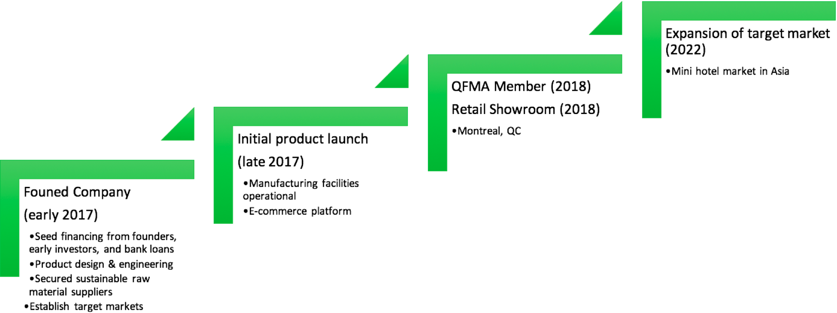

**1.2 Legal and Corporate Structure**

We are a private corporation, structured as a limited liability corporation. Our advisory board is comprised of highly influential contributors in sustainable interior design (Deborah Schneiderman, Pratt Institute of Design), sustainable furnishings (Amy Smith, Sustainable furnishings council), furniture innovation (Hervé Deschênes, FPInnovations-Forintek), and manufacturing automation (Sophie D’Amours, Université Laval). Our corporate structure is as follows:

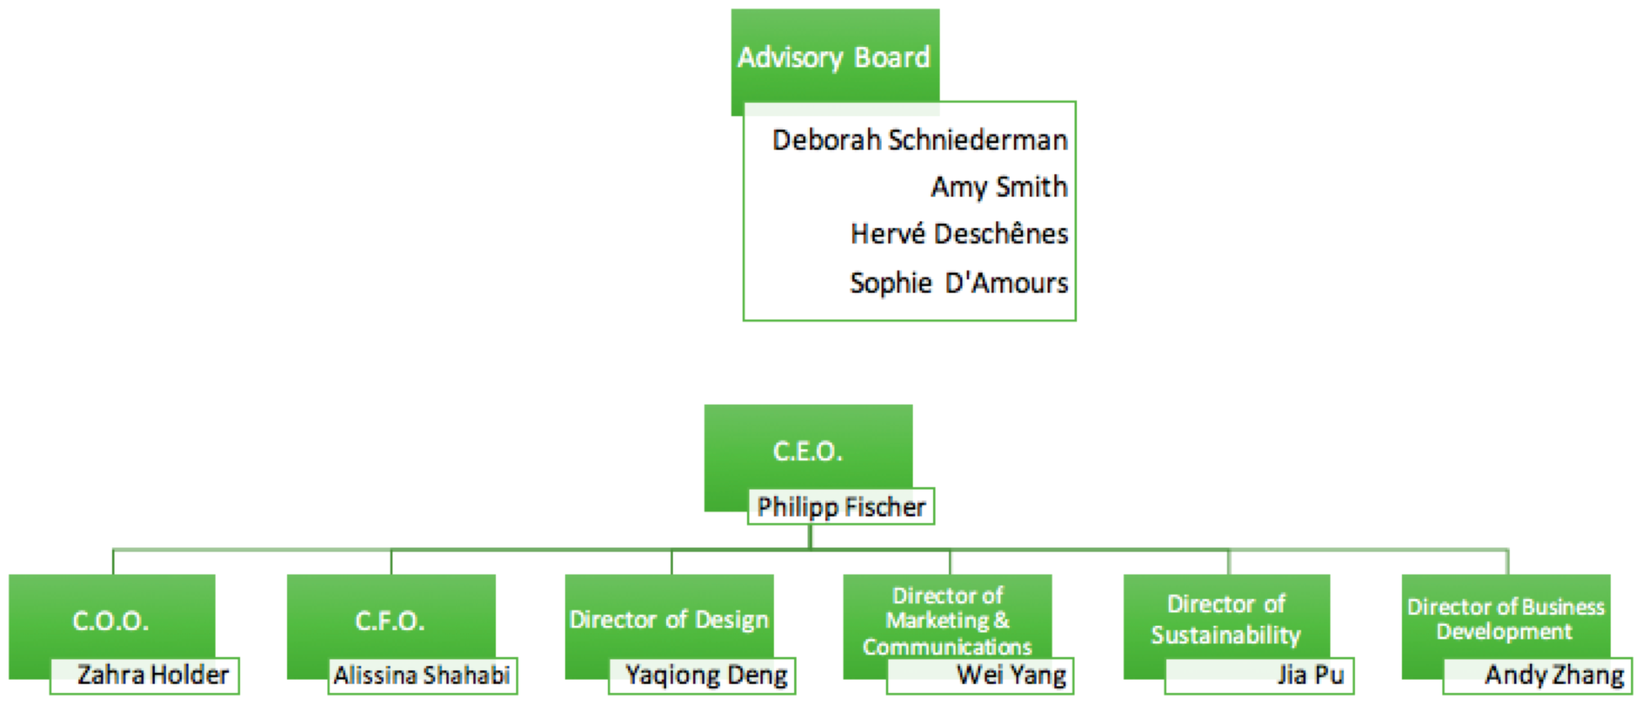

**1.3 Vision and Mission**

Our vision is to maximize living space with the versatility of our multifunctional furniture. The mission of our company is to design and manufacture multifunctional furniture starting from sustainable raw materials and responsible production practices for living spaces of all dimensions, and to provide customers with an unparalleled level of customization, flexibility, and utility. Our products will allow for a re-evaluation of the interior space through the adaptive use of furniture modules: the ability to add, subtract, or partition as needed.

Our current efforts are focused on the improvement of residential living spaces, specifically, for student apartments, millennials, small families, and short-term rentals/lodging (e.g. Airbnb) in Montreal. We aim to provide a solution to constrained living spaces and the rising expenses associated with living in urban centers. We offer the power to adjust furniture modules based on user needs. The flexibility allows for better flow within living spaces that reflects the rise of open-concept plan designs, in which interior spaces have fewer separations. This design philosophy is sustainable as a result of the customization and adaptability of the furniture modules and the use of recycled materials to promote environmental awareness. Additionally, the portability of our modules are ideal for individuals living within our global economy, as residences are constantly changing. The prefabricated design of our furniture will facilitate a streamlined manufacturing, shipping, and assembly supply chain.

Our future plans include expanding our target market to the major cities neighboring Montreal, Ottawa and Quebec City. We also plan to capture the mini hotel market in the major metropolitan areas of Hong Kong and within Japan. We believe there is an opportunity to showcase the space efficiency of our multifunctional furniture in these highly urbanized residences that face considerable size constraints. On the product and services side of the operation, we aim to supplement our product services by offering design consultancy that provides on-site customer advice on the appropriate furniture modules to purchase and how to organize their living spaces. Also, we may look to diversify our product portfolio to include multifunctional workspaces for business and commercial settings.

**1.4 Existing Customers and Partners**

Our initial client base is intended to be university students living in apartments surrounding the universities in Montreal, as well as millennials and small families living in small-homes in the greater Montreal area.

**2. Market Analysis**

**2.1 Market opportunity and sizes**

Although the Canadian furniture industry has contracted in the past decade and has gone through significant transformations, it is still the second largest consumer products sector in terms of employment and has a significant domestic presence with regional representation in every province. The Canadian furniture industry is one of the top 10 producers of furniture in the world, and represents a large open-market full of opportunities. It has maintained its reputation as a high-quality producer of furniture.

In 2015, it was estimated that there were 3,907 furniture establishments in Canada and 1,488 of those were located in Quebec. Of the Quebec establishments, 85% produced residential and industrial furniture. The furniture industry represents an important part of the manufacturing industry and represents one of the top seven employers in Quebec. Furthermore, the furniture manufacturing industry has experienced steady growth, indicated by a compounded annual growth rate (CAGR) of 3.1% in gross domestic product from 2011-2015. This is illustrated by the figure below:

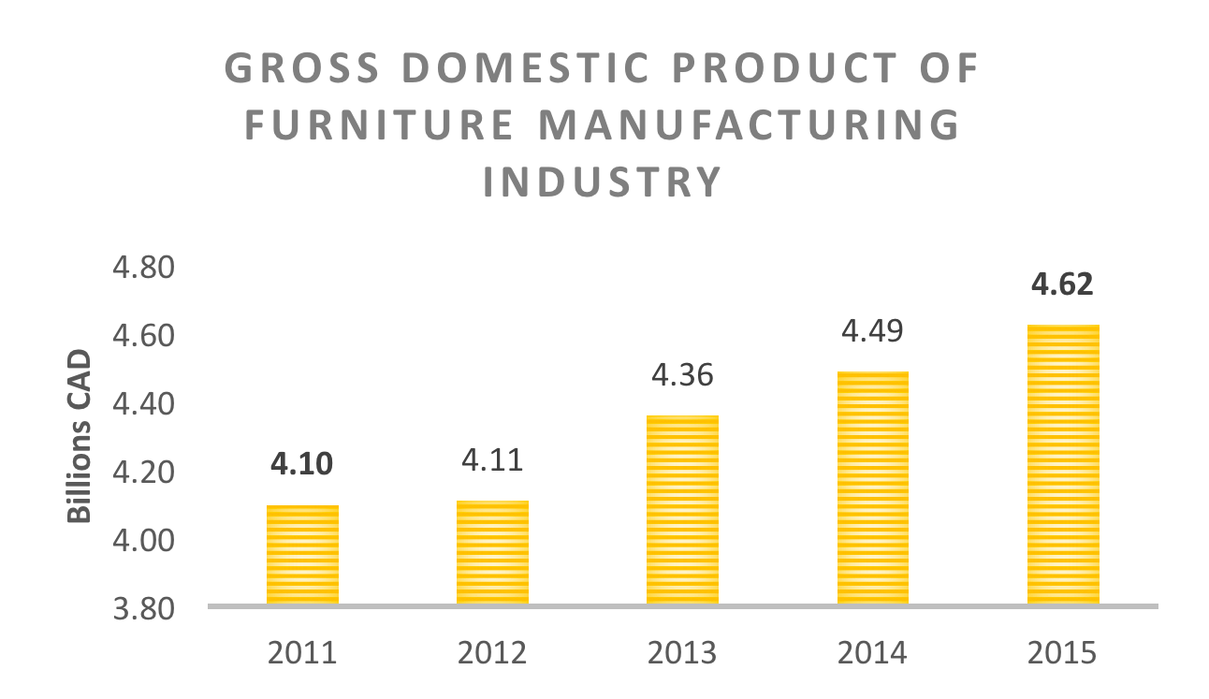

(adapted from Statistics Canada)

Additionally, retail sales of Canadian furniture and home furnishings stores have risen from 15.2 billion CAD in 2012 to 17.27 billion CAD in 2016. This is illustrated in the figure below:

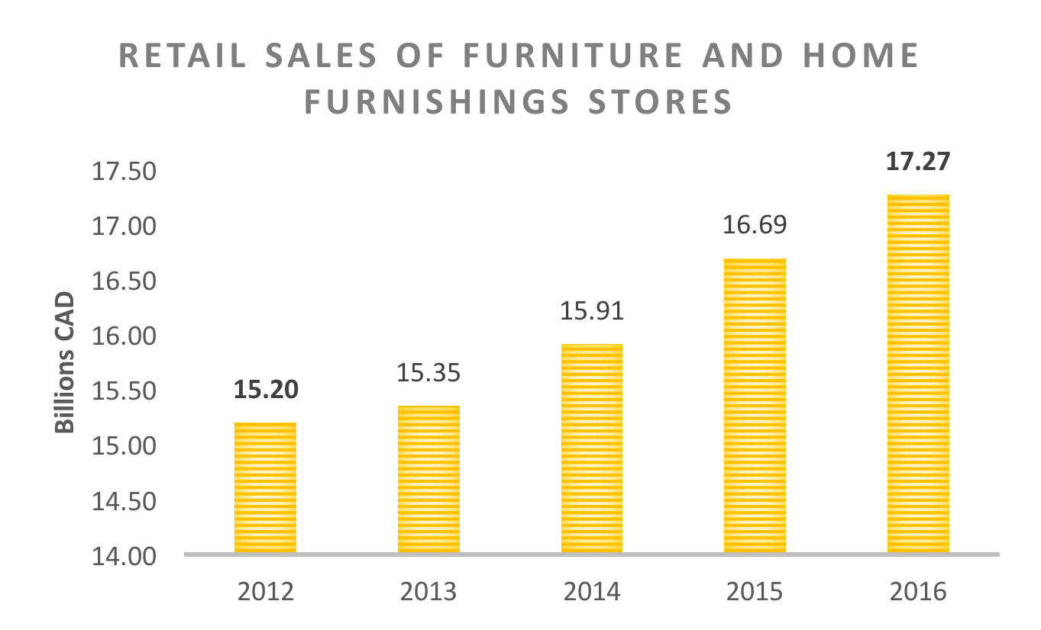

(adapted from Statistics Canada)

**2.1.1 US market overview**

A similar industry outlook is observed in the US furniture market. The recovering economic environment has coincided with the improvement of the housing market. This has created a tailwind for the furniture and home furnishings market. The US furniture market is forecasted to grow at a CAGR of 2.9% through 2019, from its valuation of 96.4 billion USD in 2014. Furthermore, furniture store sales have outpaced other retail categories, including department stores and clothing stores from 2013 to 2015 (figure shown below).

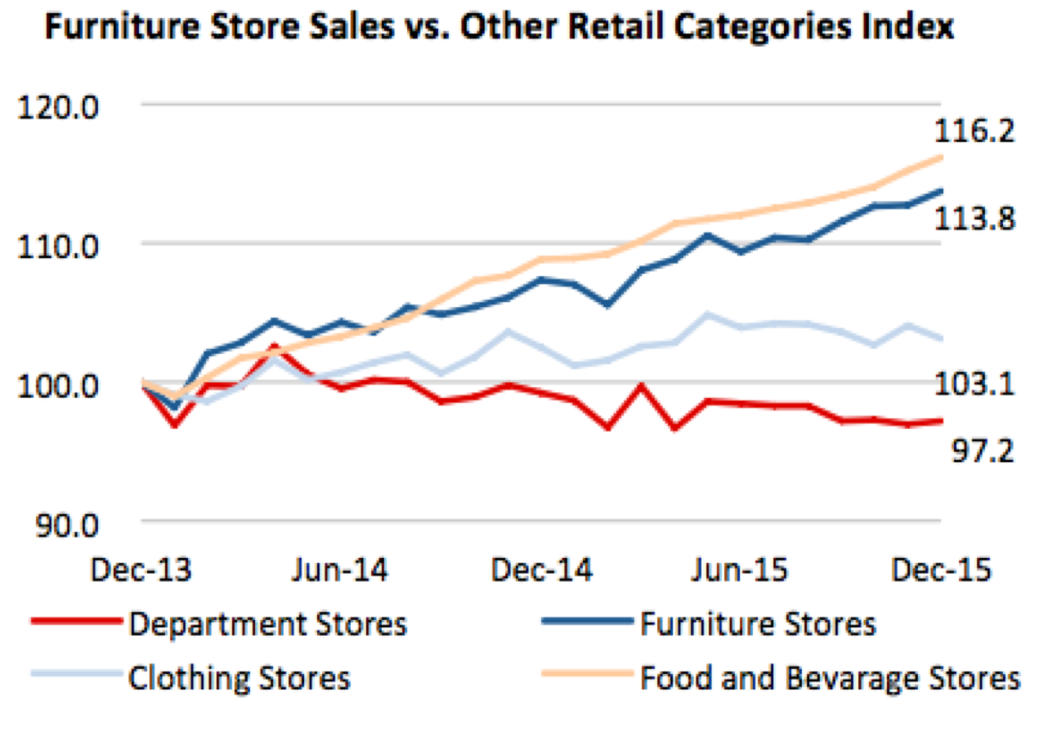

Source: US Census Bureau

Within the US furniture industry, products for the living room and bedroom dominate, representing 73% of all total sales. The furniture at G-Sustainabl will also be focused on these two areas.

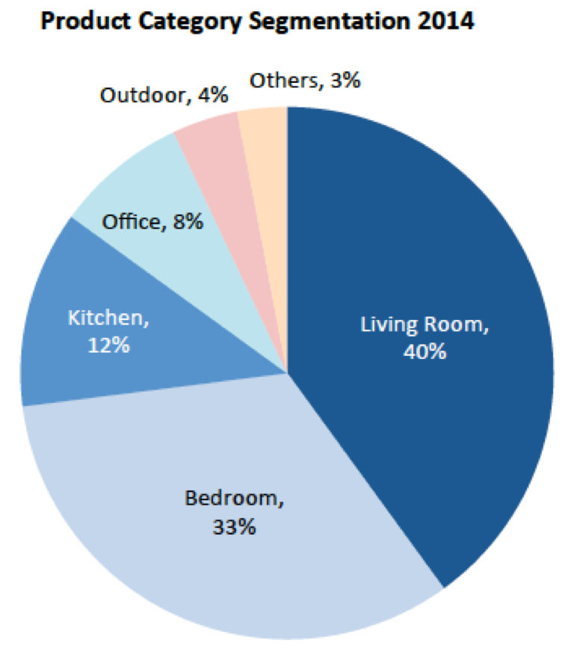

Source: Furniture Today

**2.2 Short- and long-term segments**

The short-term segment of this market is focused on the current high cost of home ownership. The lack of purchasing power has driven individuals to look for smaller residences or turn to renting. This delay in home ownership, especially within the millennial population group has led to an interest in more compact and multifunctional furniture.

The long-term segments of the market include: the increasing relevance and need for environmentally friendly furniture, the rise of e-commerce, the growing rate of urbanization, and the growing student population in Montreal. As the economy recovers, disposable incomes will grow and provide greater purchasing power to the millennial population group described in the short-term segment. We are confident that these consumers will remain loyal to our products as they purchase new homes. Furthermore, we aim to provide higher-end products to fit the aging millennial population. Each of these short-and long-term segments will be discussed further below.

**2.3 Market Trends and Drivers**

In recent years, there has been changes and new industry trends emerging under the influence of the new innovation and shifting consumer preferences. Firstly, recently there is a greater demand for flexible and portable multifunctional furniture due to the increase of small households. In addition, customers, especially those whose living space is smaller or limited, are looking for multifunctional furniture with “less is more” attitude. Secondly , going green has become another trend among furniture manufacturers. There is also an increasing demand for ecologically friendly furniture as a result of the growing environmental consciousness and concern. Considering the devastating effect of deforestation on climate change as well as the effects of toxic emissions on air , many furniture manufacturers decide to adopt more sustainable practices. Nowadays, many vendors are developing eco-friendly furniture. Although this leads to a higher price for the products, it is still worthwhile for manufacturers and companies to enter these markets because of the rising demand.

With respect to design trends, more individuals within our target market that includes young adults and millennials that are adopting a more minimalist lifestyle, preferring to reduce the clutter in their living spaces. This approach also helps reduce waste, promoting environmental awareness. Furthermore, there is greater appeal for wood as it adds a natural aesthetic and texture and is a highly durable material. This efficiency in both space and functionality is the mark of our multifunctional furniture. The interest in home decor is fueled by the growth of the real estate industry. There will be more housing opportunities to exploit, especially in metropolitan developments. Those not looking to purchase new homes may be interested in home improvement. There has also been a trend towards home automation (or “smart” homes) with the development of voice-recognition, AI, and internet connectivity technologies that offer convenience to homeowners. This provides an opportunity to integrate these technologies within our multifunctional furniture to further consolidate the needs of our consumers.

**2.4 Market Environment**

There are several key aspects of the market environment that drive the current short and long-term trends. Having personalized options in furniture is in-line with the values of university students seeking to redefine their personal image and living independently. Our multi-functional furniture offers numerous personalization options along with being space efficient, making our product an attractive choice. Furthermore, as a result of urbanization, more individuals are living downtown and seeking to start families in metropolitan areas. Our multifunctional furniture is perfectly suited for transition to urban living spaces. The political environment reinforces the trends towards environmental awareness with green initiatives being set up by the government to reach goals for sustainability. This agenda stems directly from the decline of the natural environment, leading our company to manufacture multifunctional furniture from sustainable raw materials using sustainable production practices. As our economy recovers from an economic downturn, more job opportunities are being offered as short contract work, leading to more nomadic lifestyles. The portability of our furniture will facilitate the transport of the furniture without hassle.

**2.4.1 E-commerce**

Additionally, there is a growing preference to e-commerce in this market environment, as consumers are more connected to the internet than ever before. This will allow our company to leverage social media platforms for product and brand awareness, where millennials, who are more adept at technology, are very active.

The sales forecast for the US furniture e-commerce market is expected to grow to 32 billion USD in 2018. The market share of e-commerce in total furniture sales is also forecasted to grow to 30% in 2018 (from 21% in 2014). This has convinced many large furniture retailers to adopt an omni-channel distribution strategy, combining the traditional brick-and-mortar channels (physical stores) with e-commerce platforms. Furthermore, the use of smartphones in the research and purchase of furniture is also expected to overtake computers and tablets.

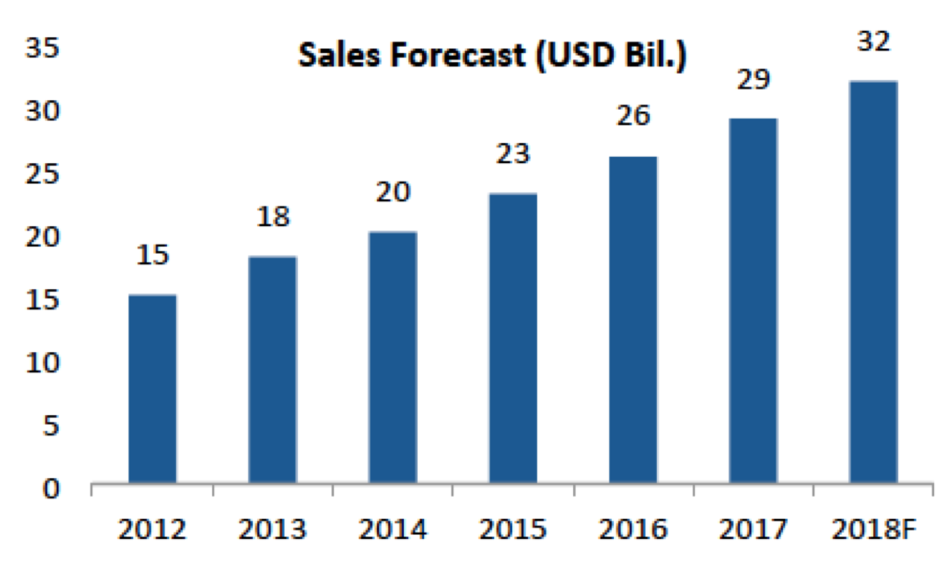

Source: eMarketer/Forrester Research

**2.5 Challenges**

The challenges in this market include the cost and supply of sustainably-sourced raw materials as the demand for these resources will rise, leading to potential shortages. The globalization of the economy has opened up the opportunity for more customers, but also more competitors overseas with the infrastructure already in place. There will be need to be a greater focus on securing sustainable resources in the future as more companies look to become more environmentally friendly. Long product replacement cycles are an inherent challenge within the traditional furniture industry. Our multifunctional furniture will combat this by offering add-ons to existing modules without the need for purchasing new furniture. However, there will be challenges to keeping pace with technological advancements and integrating them into our multifunctional furniture to stay ahead of our competitors.

**2.6 Target Customers and Regions**

Our target customer markets are ranked as follows:

**2.6.1 University students (Montreal)**

The estimated market size of university students in the greater Montreal area is over 190,000 students, and represents the highest number of students per capita amongst all metropolitan areas in North America. A market survey was conducted in 2014 by Zins Beauchesne and associates on affordable student housing in Montreal. The survey indicated that 79.8% of students resided on the island of Montreal during the school year and of these students, 71.2% lived away from home. In terms of accommodation, 49% of students surveyed rented an apartment or studio. 78% of students lived with at least one other roommate, and this was in part to save money on rent (figure below).

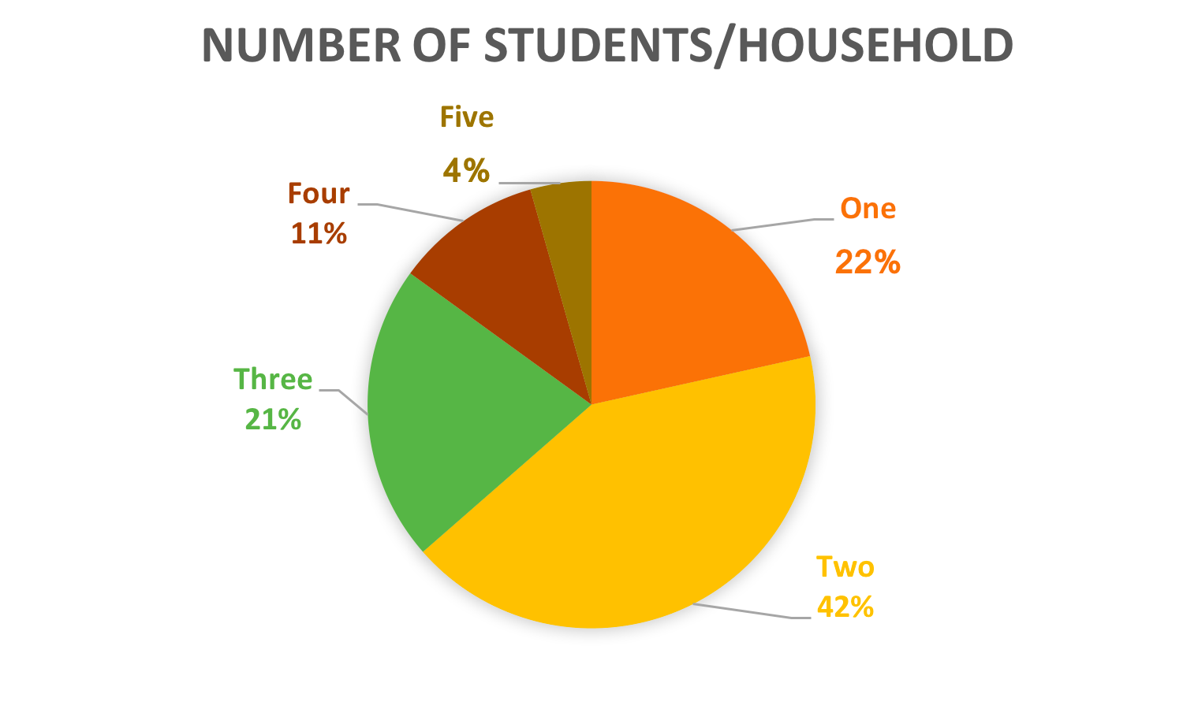

Source: Market survey by Zins Beauchesne and associates (2014)

The surveyors also noted that there is a natural shortage of on-campus housing, illustrated by the student population of over 190,000 to the 5209 available on-campus beds. A look into the Montreal rental market has shown that the vacancy rates for rental condominiums on the secondary market has remained stable despite an increase in units, indicating that there is no shortage of renters. In addition, Budget 2016 allocated over 2 billion dollars CAD to the modernization of post-secondary institution infrastructure. It has also pledged to a 50% increase in Canada student grants and the easing of loan repayment regulations in an effort to promote post-secondary education. Furthermore, the unstable political climates in the US and UK has opened up a unique opportunity for international students to consider pursuing academic studies in Canada.

**2.6.2 Millennials (Montreal)**

To analyze the great potential of the millennial target market, we will look to extrapolate from the analysis of the US market. We consider the purchasing behaviors of millennials within the US furniture market to be comparable to the Canadian market.

Based on the US furniture market report by the FBIC Global Retail Tech Group and Furniture Today, the millennial demographic has become the largest consumer group in the US furniture market. From 2012-2014, the percentage of buyers increased from 17% to 35% (figure shown below). The percentage of dollars spent also increased from 12% to 28%, while this percentage fell in the other consumer groups.

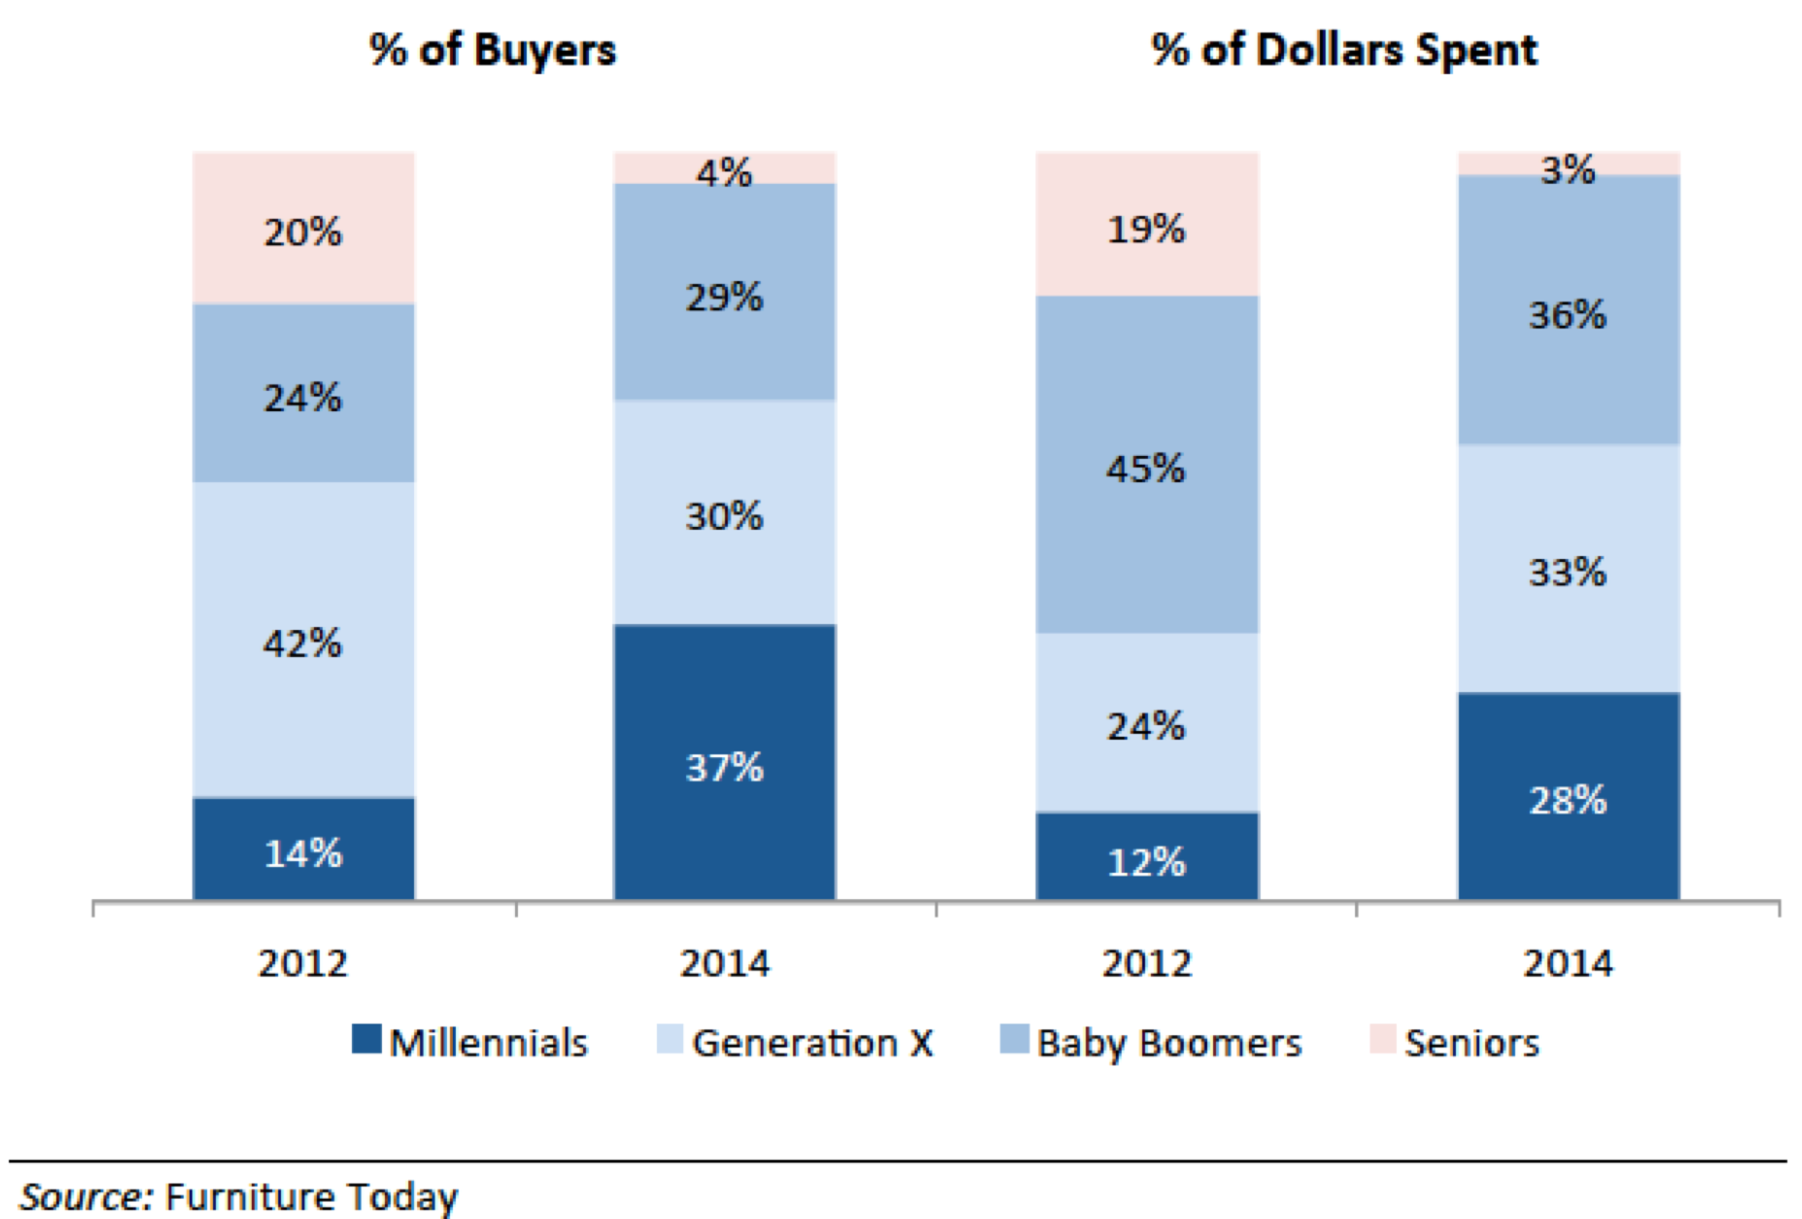

In terms of spending, this translates to a 142% increase from 2012 to 2014, the largest increase among the consumer groups.

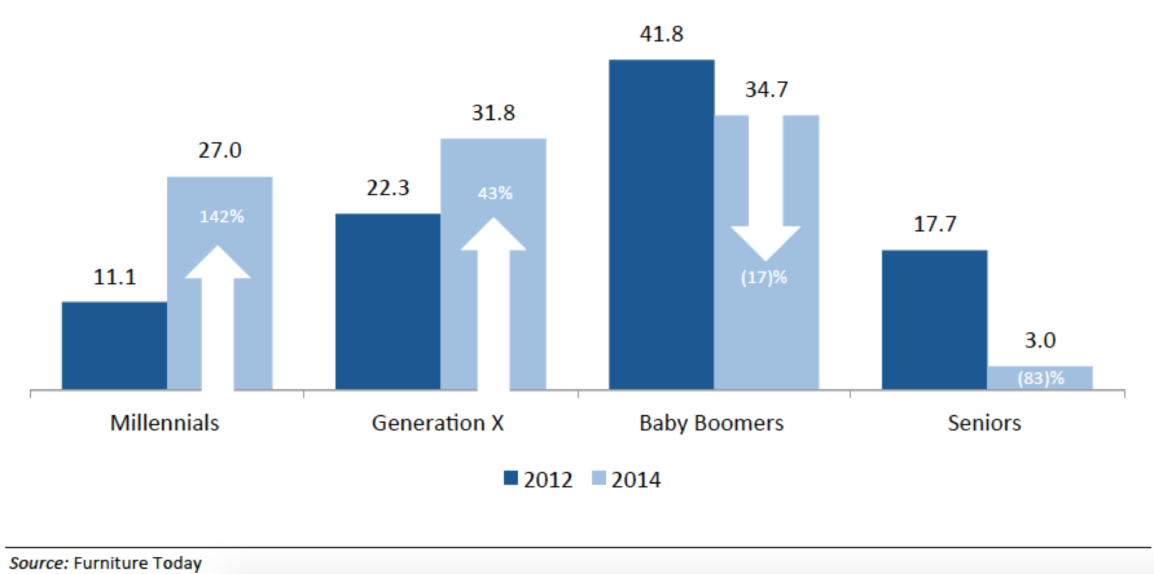

Home ownership among US millennials has dropped from 43.6% to 25.6% in 2014, as a result of many factors, including the affordability of housing, student debt, and the rise of the sharing economy. However, a study by Home Depot and Freddie Mac in 2014 showed that 57% of current millennial renters still see home ownership as a priority, the highest percentage among the consumer groups. This delay in home ownership has fueled the interest for smaller and multi-functional furniture to adapt to the more urban lifestyles of this population group.

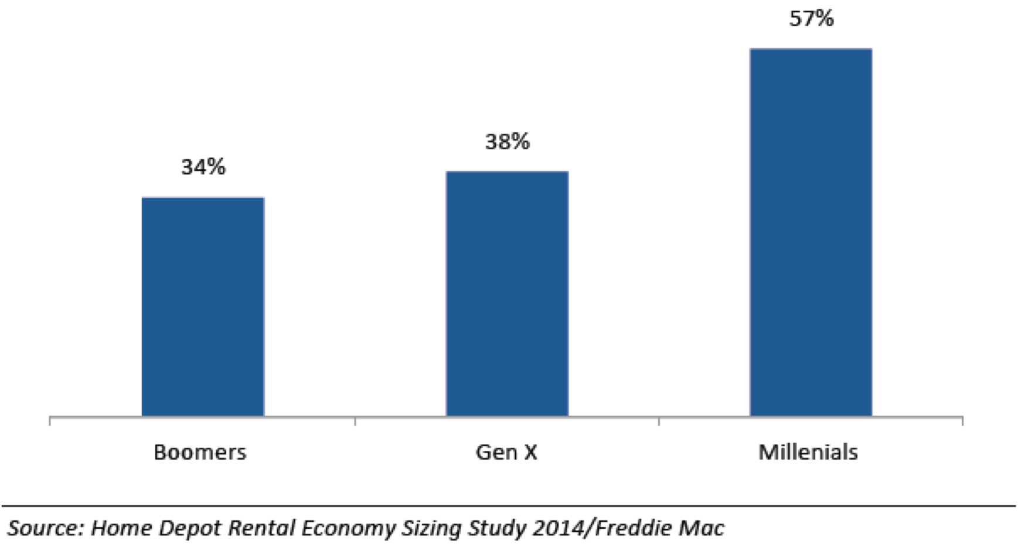

The population size of millennials in Montreal (age group ranging from 20-34 years of age) is approximately 400,000 out of a total 1,650,000, representing 25% (2011 Census profile).

**2.6.3 Small Families (Montreal)**

The number of small families (1-2 individuals) is on the rise in Montreal. In 2016, there were approximately 540,000 private households with fewer than three individuals out of 760,000 private households (representing ~70%). To further illustrate this growing trend, household sizes of 5 are decreasing whereas the household size of 1 is increasing over time.

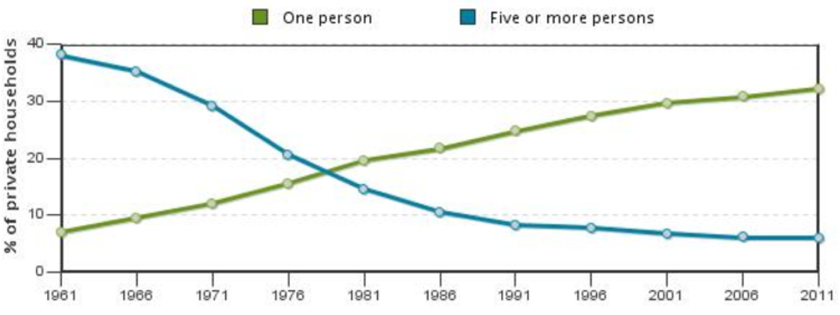

Source: Statistics Canada (2011 Census data)

**2.6.4 Short-term rentals (Montreal)**

The tourism industry of Montreal continues to see growth as Montreal has welcomed 10.2 million tourists in the year 2016, up 3.5% from 2015 (2015 Annual Report; Tourisme Montreal). This is not only restricted to tourists, but also includes international business meetings, conferences, and association meetings. The hotel industry has benefited greatly from the influx of visitors, observing increases from 2015 in occupation rates, and accommodation revenues. The Airbnb (short-term rentals: up to 12 months) landscape has also profited in parallel, with a rising number of active rentals and occupancy rates. These trends also extend to hostels that are competing with hotels and Airbnb in Montreal as well.

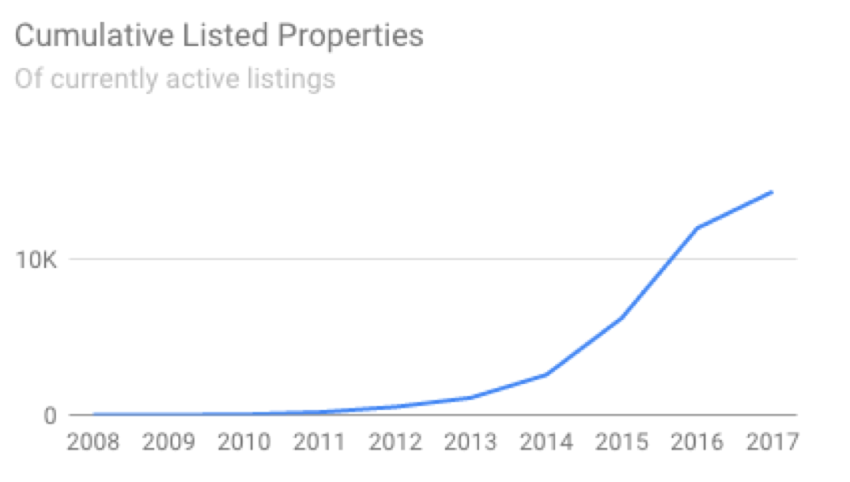

Source: Airdna, LLC (Airbnb Data and Analytics, March 2017)

**2.6.5 Mini hotels (Japan and Hong Kong)**

The highly dense and urbanized metropolitans of Hong Kong (100% urban) and in Japan (93.5% urban; Tokyo, Osaka) offer an opportunity to capitalize on the mini hotel market. Japan’s inbound tourism grew 33 percent each year from 2011 to 2015, and continues to grow, especially as the Olympic Games in 2020 reaches closer. However, all forms of accommodation are facing a severe shortage. To combat this, government initiatives are being implemented to construct new developments and ease regulations on vacation rentals (such as Airbnb). This provides an opportunity to supply our multifunctional furniture that will ease the space constraints of these developments. Mini hotel operators in Hong Kong face similar issues as a result of a high population density and would benefit greatly from innovative new multifunctional furniture designs to attract new customers.

**2.7 Phase of Market Development**

We have developed the market for university students in Montreal (student apartments), the millennial demographic, and families in small residences in the greater Montreal area. Once we become a member of the QFMA, we will work to develop our market under the distribution network of QFMA. In the future, we aim to extend our market in Montreal to the neighboring cities of Ottawa and Quebec City. Further down the road, we will develop a market within the burgeoning mini hotel sector in the metropolitan areas of East Asia (mainly Hong Kong, and cities in Japan).

**2.8 Value chain**

The figure below represents our value chain, starting from our suppliers of raw materials to our consumers. As an e-commerce platform, we place great importance on the logistics, shipping, and the design of furniture that is of the ready-to-assembly type.

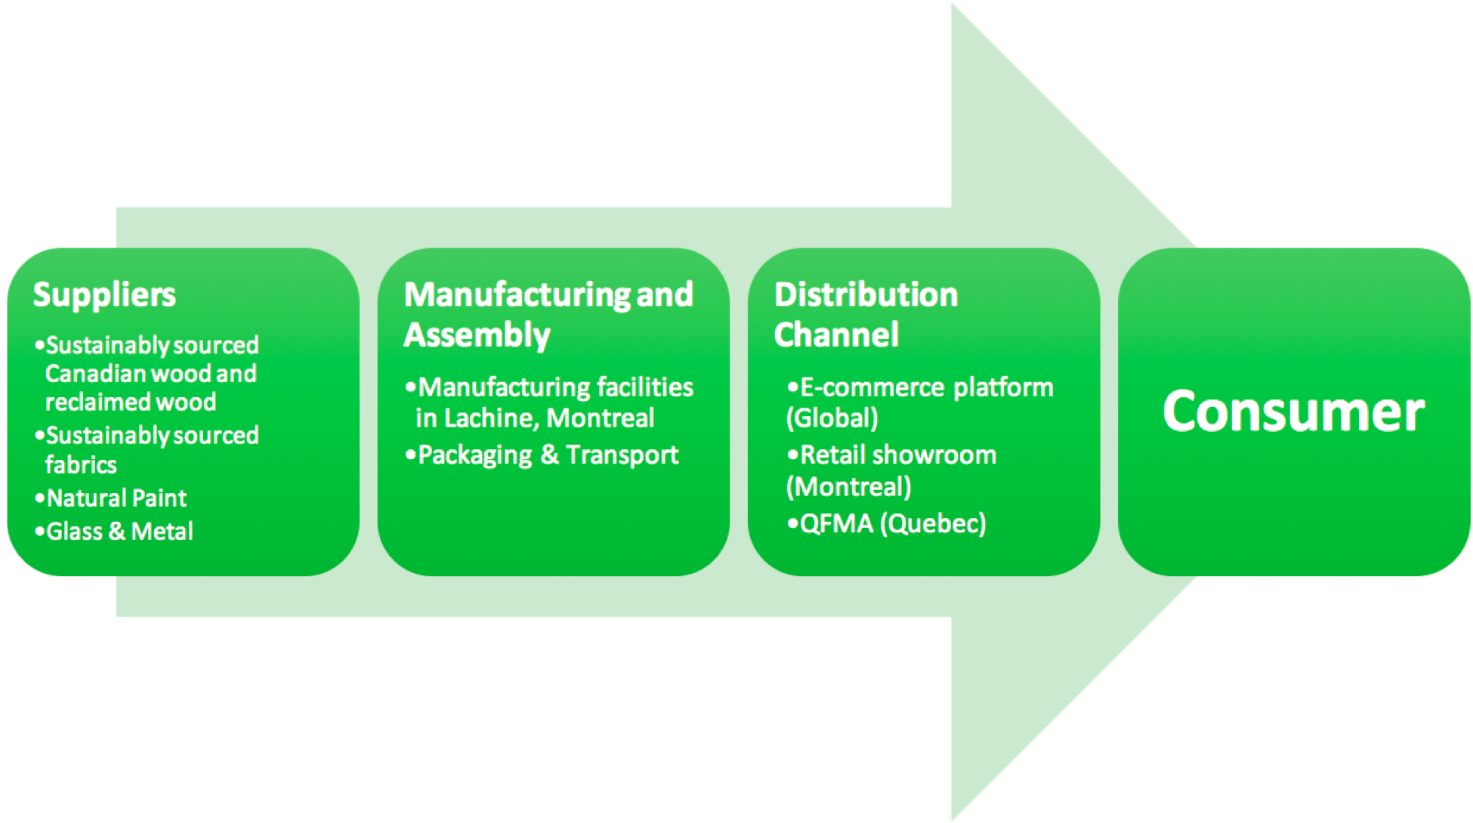

**3. Competition**

Quebec’s thriving furniture manufacturing industry, makes for a very competitive market, especially for our small company.

**3.1 Direct Competitors**

Direct Competitors would be all the furniture establishments in the Montreal area. Specifically those companies who offer the same type of service/product as our company such as Ikea and Resource Furniture.

* Ikea would be our direct competition because they sell ready-to-assemble furniture and they are the world’s largest furniture retailer since 2008 (Statista, 2016). Ikea is also known for its modern architectural designs for furniture and its interior design work which is normally categorised as eco-friendly and simple. Ikea also has a category named ‘small spaces’ that caters to customer who have small living spaces and they have a section for multifunctional sofas as well.
* Resource Furniture is a furniture company which focuses on cutting- edge space saving furniture and have collections which include furniture for small spaces such as transforming tables; coffee table that turn into dining tables. Resource furniture was also named the “ biggest retailer in the multifunctional space” by The Wall Street Journal (Resource furniture, 2017). Resource furniture have nine showrooms and one is located in Montreal. This company also prides itself on sustainability because most of their products are eco friendly and made from composite wood chips which is composed of 90% recyclable particle board, wood, glass, iron and aluminum.

**3.2 Indirect Competitors**

Our indirect competitors would be those vendors whose products or services are not exactly like ours but would be able to satisfy the consumer needs. And example of this would be like Kijiji and Pro- assemblage.

* Kijiji is an online classified advertising service that allows persons to advertise any product or item they have for sale. This includes used furniture which may be available at a reduced price.
* Pro- assemblage is a furniture assembly service located in Montreal. They assemble any type of furniture, from any retailer, inclusive of office and residential furniture. They also offer moving and delivery services for consumers who are moving residences.

**3.3 Competitive Advantage**

Our company is unique because we seek to not only create multifunctional furniture, but furniture that is environmentally friendly and is custom-designed to fit the customer’s living area. Several factors set us apart from our direct and indirect competitors such as

* Our product is of high quality and will have a lifespan guarantee of at least 5 - 10 years
* Our multifunctional furniture is space efficient and versatile.
* Our small size as a company allows our product quality to be maintained while larger companies over time find it hard to maintain their quality from country to country and have major problems with quality control.
* Our company focuses on function being equal to comfort and ergonomic design of the furniture we produce is important. We have a strong design team whose focus is on designs which are trendy, functional and comfortable. Our design team ensures that our products are refined so that optimum customer satisfaction is achieved. Some of our competitors focus on comfort as secondary to price and function creating a product that is fit for purpose but not fit for use.
* Our product is environmentally friendly. Most of our competitors do not offer that factor in their products. Therefore we cater to persons who are environmentally-conscious and want to associate themselves to brands that care about preserving the environment. The reclaimed wood which we utilise preserves our forest by reducing the need for virgin timber. Reclaimed wood also requires less processing which reduces the impact on the environment. The natural paint which we will use comprises of natural components which are biodegradable and do not contain any volatile organic compounds (VOC). These VOC can remain active up to five years and have been known to cause lung cancer to persons exposed.
* Our product requires minimal assembly and is therefore not complicated to assemble.

**3.4 Advantage of Subcontracting**

Joining Quebec’s Furniture Manufacturers Association (QFMA) will allow us further access to the industry when we partner with companies within the association on a subcontract basis which allows our product to be marketed and sold through these various companies.

Choosing to expand our market base as subcontractors allowed us to work with companies that did not offer the service or product we offered and who were willing to diversify with our niche product.This approach allowed us to have a lower business development cost because we did not have to work on capturing a large clientele (public) only focused on big clients (companies) which had the financial and marketing means to capture the clients. Also because we offered a specialized product we are able to cater to large companies that are looking to diversify their enterprise and to carry more specialized products. This allows our company to gain experience in half the time because we were are given access to project opportunities by which we would have never been able to do on our own. Another advantage was seen in gaining links to past performances based on the already established company that we were working with (NIBusiness Infor. CO. UK, 2016). The reputation of the company allowed for future work to be easily acquired because of the good track record which they had previously. There are two companies within QFMA which we decided to enter into a subcontract partnership with; Nexera and Bestar because they share a similar vision to our company and were also supplying ready to assemble furniture. The multifunctional features of our furniture would allow them to diversify their product and expand their product base for their clients.

* Nexera is a company which designs and manufactures contemporary ready- to- assemble furniture for residential homes.
* Bestar Inc is a company which has over 60 years of experience in the furniture business with their primary customer based being families. They emphasize high quality products with a 10 year guarantee on their products. Bestar Inc also is eco- friendly through their packaging method which eliminates the need for polystyrene.

**4. Products**

**4.1 Description**

Multifunctional furniture is a piece of furniture with more than one function, which promotes the “less is more” attitude towards interior design. Plus, with fewer and recycled materials, it can also be a sustainable alternative to traditional furnishings.

Our company offers high-quality green and multifunctional furniture, specifically for small families and student apartments. The design of the furniture adopts unique Mortise-Tenon joint and multifunctional structure. Also, environmentally friendly and recycled materials are used in our design, which maximizes customers’ living space and develops an enjoyable living environment.

Our products are mainly for living room and bedroom, including table-bed, wall-bed, expandable table and smart shelf.

* Table-bed: With an easy one move, the customer can transform the bed into a table. The table-bed adopt reclaimed wood and natural paint. The bed is available in single, twin, queen and king size.
* Wall-bed: The wall-bed, equipped with bedside table, can be stored vertically inside a cabinet with three small angle brackets, providing the customer with either an open area or a comfortable bed. Our wall-bed is made of reclaimed wood and employs natural paint. It is convenient for the customer to install. Three choices of size (single, twin or queen) and multiple choices of colors are now available for this product.
* Smart Shelf: Smart shelf makes the use of Mortise-Tenon Joint so as to keep stable as well as bring convenience to assembly. Customers can design their own ideal shelves according to individual needs.
* Expandable Table: Expandable table can be converted into a large table. The use of Mortise-Tenon Joint offers a strong leg frame. With the help of the slide , it can be expended to a titan kitchen table. And two additional support legs can be hidden in the center of the table.

**4.2 Product Features**

**4.2.1 Mortise-Tenon Joint**

One of the salient features of our products is the application of the mortise-tenon joint, which originated in ancient China. Woodworkers around the world have been using it for thousands of years to join wood. The mortise-tenon joint is not only simple but also strong in its basic form. The tenon is formed on the end of a piece of wood and is inserted into the mortise, which is a square or rectangular hole cut into the corresponding piece of wood. The tenon is cut to fit the mortise exactly. Instead of using nails, the joining of the mortise and tenon is usually made permanent by gluing, pinning, or wedged, which is environmentally friendly and helps save energy.

**4.2.2 Environmental Footprint**

Our company is devoted to building an environmentally friendly business and to creating more flexible, healthy and comfortable living spaces for customers.

**4.2.2.1 Materials**

Our products employs environmentally friendly materials that include the following:

* Sustainable and Reclaimed Wood：sustainable wood refers to the wood grown and harvested in eco-friendly forests. Due to our cooperation with local wood suppliers such as Resolute Forest Products and DV Hardwoods, we have easy access to sustainable wood as well as reclaimed wood. These suppliers are certified by the Forest Steward Council (FSC), which oversees the sustainable management of the forests from which the wood is sourced. We are also cooperating with the international wood supplier, Resolute Forest Products (based in Canada and USA), which is certified by the Programme for the Endorsement of Forest Certification (PEFC). PEFC is an international non-profit and non-governmental organization that also promotes sustainable forest management. These materials have a positive impact on our environment. Plus, according to our research, rustic style has gained popularity and reclaimed wood can bring rustic textures into your house design.
* Reproduced Fabrics: in our latest search for recycled materials, we discovered a fabric that is environmentally friendly and can endow our products with a modern look: vintage military canvas, which is a durable and recyclable cotton canvas. Also, recycled denim is adopted in our design due to the durability of the material.
* Natural Paint: we employ natural paint rather than the traditional latex paint in order to provide you a safe and eco living environment. Natural paint is usually made with raw ingredient such as chalk, marble, clay and so on, which is biodegradable and free of petrochemical ingredients.

**4.2.2.2 Packaging**

We are devoted to protecting the environment. Most of our products are packaged in recycled cardboard as well as brown boxes that are bleach-free. Environmental-friendly materials are employed to reduce waste. We will keep sourcing more environmental-friendly materials to package our products and increasing the percentage of recyclable materials used.In the near future, many of our products will be packaged with materials that are 100% recyclable.

**5. Services**

**5.1 Purchasing Support**

We promise to provide our customers the best and most comfortable service, including 24 hours free-online/toll-free call consulting service. Customers can complete the purchase with us through the following steps.

Step 1: Contact us through telephone (438-929-2841) or email (multi-functional furniture@gmail.com), providing the basic information of the customer's house or apartment (24 hours with the fast and efficient response).

Step 2: Our customer representative will get in touch with the customer within 24 hours to arrange a decoration consultant.

Step 3: Our decoration consultant will provide the customer with advices on the style, size, color, setting of the furniture, etc after checking the room on site. The in-door service will be free the first two times to make sure the customers will have enough time to choose the most suitable furniture.

**5.2 Delivery**

Step 4: Once confirmed, the furniture will be delivered to the customers’ place within 1-2 weeks. Packaging removal, professional assembly and cautious placement will be guaranteed . Assembly is free of charge for all our products and there is a flat rate delivery fee for all orders delivered within the store's normal trade area.

Our company is featured in providing a great variety of products based on the customers’ need within a short time. We guarantee all the products our customers ordered can be delivered to their places within 1-2 weeks. A majority of our selection can also be customized, production time for custom-made special orders is 4-5 weeks.

**5.3 Product Support**

Step 5: The furniture maintaining service is free within the first three months of any purchase if the damage is not caused purposely. The customers can call us through our 24 hours furniture maintaining department. The in-door maintaining service will be arranged within 2working-days.

**5.4 Return and Exchange Policy**

If the customers are dissatisfied with their purchase, they are naturally entitled to return it within five days as long as the products are not used and the original packages are kept well. However, there will be a restocking fee of 25% of the purchase price applied to all furniture orders. If the customers need our company to pick up the furniture from their place, a delivery fee will be charged. But any items bought on sale cannot be returned.

**5.5 Quality Assurance**

In order to make sure all of materials are 100 percent safe and sustainable. We have a comprehensive quality-control programme based on the ISO 9000 standard and our material suppliers are all the companies who produce the materials which can meet the quality requirement. Moreover, our quality control engineers will inspect the production process of our suppliers to make sure the great quality of all our products before leaving the factory.

All our furniture is a great combination of high-quality components and our goal to product the most convenient and multi-functional product. To achieve this, we dedicated to achieving the great combination of innovative design, carefully selected materials and deliberate simplicity.

**6. Sales and Marketing**

**6.1 Marketing Strategy**

Our marketing strategies are based on providing details about our products, making the right information available to the customers and conveying the sense of quality in every picture and every promotion.Our marketing strategies are as follows:

* Website: we make our own company website and post our link through some popular social media such as facebook, twitter, Instagram and so on. In the website, we offer information about our company, service and contact, high quality pictures of our products with full illustration, videos about the instruction to use multifunctional furniture. Moreover, we also provide 3D planning tools, through which customers can design their ideal space with our products. They can print their complete product list and review. And customers can leave their feedback in the feedback sheet.
* Advertisement: since we are going to cooperate with companies in QFMA and student apartments, we ask them to put our space-limited ads or use our pictures of products on their website and promotion posters.
* Exhibitions: We will attend relevant exhibitions, such as Canadian Furniture Show and SIDIM Design Show, to display and promote our products.

**6.2 Sales Strategies**

Following the Marketing Theories of 4ps(price, product, promotion and place), our sale strategies are as follows:

* Price: in order to boost our sale volumes, we encourage customers to become our VIP member and buy the combo products by providing 10-20% discounts.

1. Combo sale: The product we provide is featured by its multifunctional and space-saving. One product can be used in several different ways while a combination of two products can give the customer a feeling of whole-furnished home. We encourage customers to purchase the combo products so as to make the house design unified and harmonious. In order to achieve that goal, the price of a combo will be 10-20% lower than the original pieces.
2. Points System and VIP member: We set up a points system. The price of the products a customer buys can be transferred to the credits. When 3,000 points are accumulated, the customer will become our VIP member. Any customer who buys a combo of our products will become our member at once. The company will give VIP members 20% discount the next time they purchase.

* Product: we believe that keeping innovation is the key to gain success so our company pays more attention to creative design and decides to regularly introduce new products and display it on our online store.
* Promotion: for the short-term promotion, we will invite some customers to try our products first at a lower price and receive feedback from them, which is mutually beneficial for the products’ sale and improvement.
* Place: except for online store, we also seek for various channels to help us sell products so we supply our products to student apartment and companies in QFMA.

**6.3 Channel Sales and Direct Sales**

Our company has both channel sales and direct sales. Since we are going to cooperate with larger well established furniture companies in QFMA, we supply them with our products to sell. Given we also have the target customers student apartment and mini-family, we set up online store for them to purchase our products. Customized design service is provided. The customers can be assess to either the onsite or online store to browse the products, use our planning tools, consult with our service technician and buy products.

**6.4 Revenue model**

We have two revenue models:

* Selling physical goods. Our products can be accessed at both our online shop
* A service with fixed price. We also offer customized design service, which is charged in accordance with the size of space, the material use and so on.

**6.5 Sales Funnel**

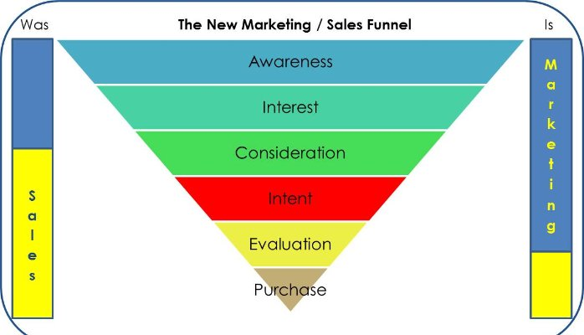

Figure 1

In terms of sales funnel, we follow the pattern as the figure 1 shows:

* Awareness: The limited space and environmental-protection awareness is attracting an increasing number of attention in the world. According to relevant research, people are very interested in having a multifunctional and environment-friendly furniture at home. This new taste for the furniture is giving our company a great opportunity to boost our sales.
* Interest: Our advertisement will raise our potential customers interests through a great number of channels, such as facebook, twitter, newspaper, etc. Anyone who are interested to know more can find our contact information and website easily.
* Consideration: From the first contact with our company, we will provide the most comfortable service and comprehensive information to our potential customers. In-door consulting service will fortify the possibility of their purchase.
* Intent: When the customers show their intent to buy the products from us, it is the great moment of providing a comprehensive introduction of our featured products and the distinctive advantages of choosing our company. A follow-up emphasizing of potential discounts and gifts will increase the possibility of purchase.
* Evaluation: Knowing our competitors well gives us a great confidence to win the customers during this phase, besides the concept of multi-functional, our products are also featured in its modern and innovative design, environmental-friendly materials and trustworthy quality.
* Purchase: Our company aims to provide the best products and service to every customer, once confirmed the purchase, we will ensure that every customer will be entitled to enjoy all the rights included in the contract. Follow-up purchase-satisfaction survey and services will be implemented to ensure the continuous improvement of our products and customer services, which may expand one more sales channel of our company by turning every customer of us into our economic and vivid brand advocate.

**7. Operations**

**7.1 Information technologies – integrated sales & production management**

Our production equipment is closely related to our work units, this gives gives us the flexibility and ability to quickly produce a good variety of different furniture. Our information technologies are also used to integrate our sales and production, this helps us customize our procedures and keep the customer at the heart of the business's strategy.

Our integrated sales management systems guaranties a quality answer to customer enquiries, account requests, inventory or real-time synchronization requests, online orders, and others. The value chain is therefore optimized, and efficiency and efficacy are increased due to faster delivery.

Our integrated production management system and procedures also optimize service through our just-in-time inventory management and the ability to track shipments using our system that is linked with our transport partners ensuring efficiency. Our design and computer-assisted production system, which facilitate prototyping and quick fixes, permit us to place customers at the heart of our strategy. The first priority of our business is to answer the people’s needs.

Our obligation to excellence does not end with manufacturing. The technology used, such as the information systems that take care of internal processes and the automated ordering & delivery, is the key for quick-response production, without sacrificing quality or cost.

**7.2 Quality**

A quality control process is integrated into all parts of production, from buying raw materials to customer delivery. We are proud to be part of the Canadian furniture manufacturer network producing quality canadian furniture.

We have been aiming to improve our packaging and related processes. Our ISTA Certification promises that our furniture resist compression, random vibrations , incline shocks, and rotational edge and corner testing. This commitment to quality ensures nuisance-free furniture transportation for our customers

**7.3 High-Tech Equipment**

Our advancing investments in high-tech equipment allow us to meet the high expectations of our customers. In this way, we produce a large amount of different parts with repeated accuracy, piece by piece. In doing so, we are able to produce batches starting from 25 units to 10,000, in a large variety of sizes and finishes. The competences of our workforce, the good adaptability of our production and the performance of our equipment ensure compliance with the strict standards set by our customers.

**7.4 Facilities**

In addition to our facility in Canada, our furniture company also maintains a large facility in China in order to reduce costs. With two locations, the company has the adequate manpower and technical resources to produce numerous amounts of simultaneous orders, large or small. During peak periods, trucks leave the furniture facilities daily to deliver and install its products across Canada seeking to grow to north america. Our furniture company designs, develops and makes our furniture using hi-tech computer controlled machinery. With a fully automated production system, we can manufacture every product with extreme precision resulting in perfectly assembled and always identical furniture.

**7.5 Personnel**

The company will have the following staff members:

* Manager;
* Assistant manager;
* Office manager/accountant;
* Checkers (1.5);
* Production staff (5);
* Stockers (1.5);

**8. Financial Plan**

**8.1 Income Statement Assumptions – Revenues**

The first month considered in this business plan is May, 2017. The team has developed these projections and considers results anticipated as reasonable and achievable. Although all assumptions are supported, the team cannot make any assurances that actual results will meet expectations. At the beginning, the company plans to target the low-end segment. However, starting in the second year, the company plans to introduce higher-quality models made from better wood that will target a higher segment of the population. In forecasts, low-end products are designated Model A and high-end ones are designated Model B.

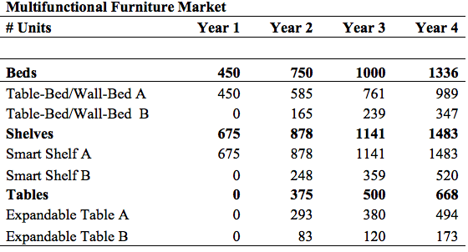

The team has decided on pricing as a function of marketing positioning strategy, and also with consideration of manufacturing costs.

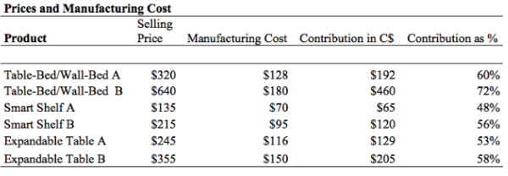

The only distribution considered by the team is directly selling products to customers online. Starting in the second year, the company will also open a flagship store in Montreal, QC. Revenues are expected to increase significantly for the low-segment products around August when the university year begins and students are looking to furnish their apartments, and sales of the high-end product are expected to peak during the winter holiday season when individuals with greater income will gift the products.

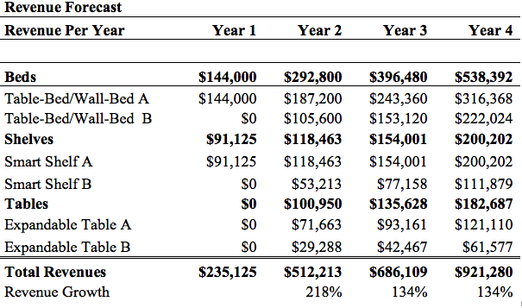

**8.2 Income Statement Assumptions - Cost of Sales**

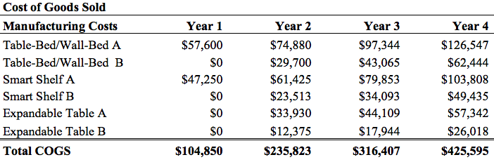

**8.3 Income Statement Assumptions - Expenses**

Expenses for the company can be categorized in three parts:

1) Marketing: Generating the website and marketing materials, in addition to a direct mail campaign, will be the main sales and marketing efforts in the first year. In the second year, with the initiation of the high-end line, marketing strategy will intensify to target the different customer segment.

2) Administration: The administrative costs considered are industry average. The company plans to keep the team of six individuals for the first four years and relocate to a new facility by year 2.

3) Product development: Since innovative products is the core competency of the company, product research and development will be allocated a significant amount.

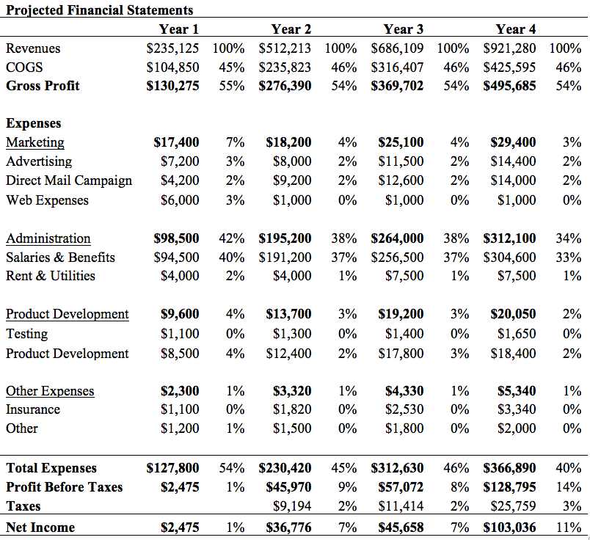

**8.4 Balance Sheet Assumptions**

Inventory is kept at 45 days, or 8 inventory turns per year. This level of inventory is justified by the fact that most sales are directly to the customer. Direct sales means there will be limited accounts receivable, coming mostly from customers who pay by credit card. Accounts payable will be 25 days for the first four years until trust is established with supplier, at which time the period will be lengthened. The company will be funded primarily through long-term debt, and a small amount will also be funded by friends and family of the founders. The long-term debt is taken to be $200,000 at 10% annual interest rate, which will be paid back in five years.

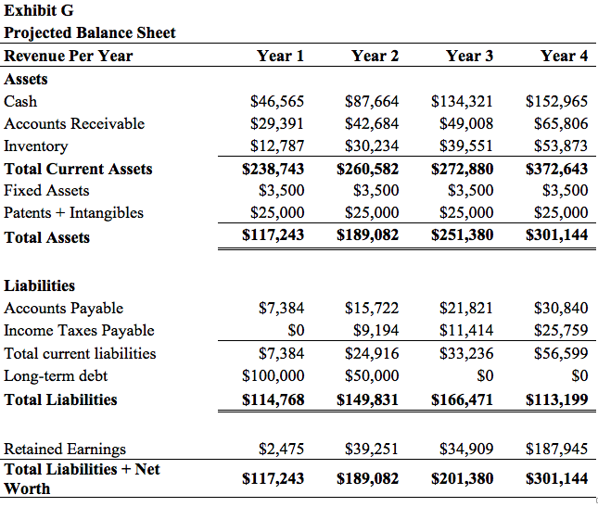

**8.5 Cash Flow Assumptions**

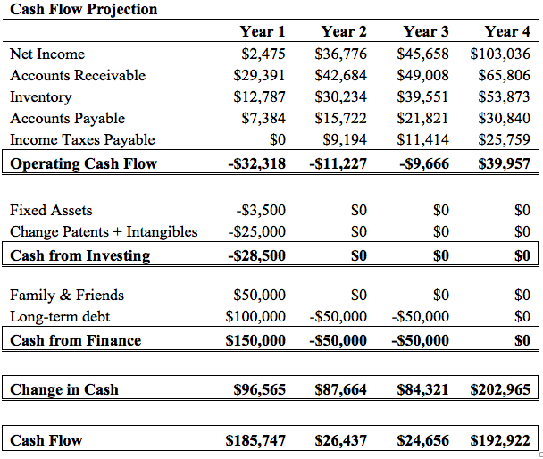

**9. Exit Strategies**

A market analysis by the FBIC Group has indicated that the US furniture industry has become less fragmented over time, with the largest companies absorbing more market share from smaller retailers. In 2006, the top 100 furniture retailers accounted for 59% of the industry revenues, but this has ballooned to 79% in 2014. Factors include the expansion of e-commerce segments within these retailers, in addition to the optimization of distribution networks. Therefore, a merger or acquisition is the most likely exit strategy for our company, as the larger furniture retailers will have the complementary assets to expand on our products and distribution network.

**Appendix I: SWOT Analysis**

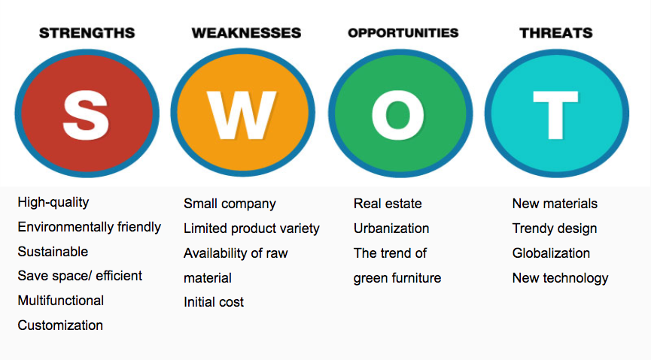

**Appendix II: References**

Airbnb data

<https://www.airdna.co/city/ca/montreal#>

Figure 1--- Sales Funnel

<https://www.linkedin.com/pulse/all-new-marketing-sales-funnel-simon-tempest>

FBIC Group - US furniture market report

<https://www.fbicgroup.com/sites/default/files/US%20Furniture%20Market%20Report%20by%20FBIC%20Global%20Retail%20Tech%20Feb%209%202016.pdf>

Japanese tourism statistics

<http://blog.btrax.com/en/2016/10/26/road-to-2020-the-future-of-tourism-in-japan/>

NIBusinessInfo. Co. UK. (2016). Using Contractors and Subcontractors. Retrieved from <https://www.nibusinessinfo.co.uk/content/advantages-and-disadvantages-using-contractor-or-subcontractor>

PHARE survey - Zins Beauchesne and associates

<https://csu.qc.ca/sites/default/files/PHARE%20survey%20summary%20-%20English.pdf>

Resource Furniture. (2017). Space Reinvented. Retrieved from <http://resourcefurniture.com>

Statistics Canada - Furniture manufacturing industry data

<https://www.ic.gc.ca/eic/site/026.nsf/eng/h_00073.html>

Statistics Canada - Retail Sales data

<http://www.statcan.gc.ca/tables-tableaux/sum-som/l01/cst01/trad42a-eng.htm>

Statistics Canada - 2011 Census data

<http://www12.statcan.gc.ca/census-recensement/2011/as-sa/fogs-spg/Facts-pr-eng.cfm?Lang=eng&GC=24>

<http://www12.statcan.gc.ca/census-recensement/2011/dp-pd/prof/details/Page.cfm?Lang=E&Geo1=CSD&Code1=2466023&Geo2=PR&Code2=24&Data=Count&SearchText=montreal&SearchType=Begins&SearchPR=01&B1=All&Custom=>

Statista. (2016). Statistics and Facts on IKEA. Retrieved from <http://www.statista.com/topics/1961/ikea/>

Tourisme Montreal statistics

<http://www.octgm.com/toolkit/fr/statistiques/bilan-annuel-2016.pdf>